**ASSIGNMENT 5**

**Samarth Patel**

**22070126098**

Write Menu Driven program to calculate the Area and Volume of the selected Shape  
a) Create classes as Circle, Rectangle, Square, Sphere, Cylinder, and Pyramid.  
b) Create Shape as abstract class with showShape(String shape) as non-abstract method,while calculateShape() and calculatePerimeter() as abstract method.  
c) Create Volume as an interface with calculateVolume() as an abstract method.  
d) Get input from users for measurements of shapes

**Code:**

interface Shape{  
 public double area();  
 public double perimeter();  
}

public interface Shape3D {  
 public double SurfaceArea();  
 public double volume();  
  
}

public class Circle implements Shape {  
 private double radius;  
  
 public void setRadius(double radius){  
 this.radius = radius;  
 }  
  
 public double getRadius(){  
 return radius;  
 }  
  
 public double area(){  
 return Math.*PI* * Math.*pow*(radius, 2);  
 }  
  
 public double perimeter(){  
 return 2* Math.*PI* * radius;  
 }  
}

class Sphere implements Shape3D {  
 private double radius;  
  
 public void setRadius(double radius) {  
 this.radius = radius;  
 }  
  
 public double getRadius() {  
 return radius;  
 }  
  
 public double SurfaceArea() {  
 return 4 * Math.*PI* * Math.*pow*(radius, 2);  
 }  
  
 public double volume() {  
 return (4.0 / 3.0) * Math.*PI* * Math.*pow*(radius, 3);  
 }  
  
 public double perimeter() {  
 // There's no perimeter for a sphere, so we can just return 0  
 return 0;  
 }  
}

class Cylinder implements Shape3D {  
 private double radius;  
 private double height;  
  
 public void setRadius(double radius) {  
 this.radius = radius;  
 }  
  
 public double getRadius() {  
 return radius;  
 }  
  
 public void setHeight(double height) {  
 this.height = height;  
 }  
  
 public double getHeight() {  
 return height;  
 }  
  
 public double SurfaceArea() {  
 return 2 * Math.*PI* * radius * (radius + height);  
 }  
  
 public double volume() {  
 return Math.*PI* * Math.*pow*(radius, 2) * height;  
 }  
}

public class Pyramid {  
  
 private double base;  
 private double height;  
  
 private double slant;  
  
 public void setBase(double base) {  
 this.base = base;  
 }  
  
 public double getRadius() {  
 return base;  
 }  
  
 public void setHeight(double height) {  
 this.height = height;  
 }  
  
 public double getHeight() {  
 return height;  
 }  
 public void setSlant(double slant) {  
 this.slant = slant;  
 }  
  
 public double getSlant() {  
 return slant;  
 }  
  
 public double SurfaceArea() {  
 return 2 * base * slant + (base*base);  
 }  
  
 public double volume() {  
 return (1/3)*Math.*pow*(base, 2)*height;  
 }  
}

import java.util.*;  
  
public class Main {  
 public static void main(String[] args) {  
 Scanner scan = new Scanner(System.*in*);  
  
 System.*out*.println("Enter the radius of Circle in cm:");  
 double radius = scan.nextDouble();  
  
 Circle circle = new Circle();  
 circle.setRadius(radius);  
  
 System.*out*.println("Area of Circle is:" + circle.area());  
 System.*out*.println("Perimeter of Circle is:" + circle.perimeter());  
  
 System.*out*.println("Enter the radius of the sphere in cm:");  
 double sphereRadius = scan.nextDouble();  
  
 Sphere sphere = new Sphere();  
 sphere.setRadius(sphereRadius);  
  
 System.*out*.println("Surface Area of Sphere is: " + sphere.SurfaceArea());  
 System.*out*.println("Volume of Sphere is: " + sphere.volume());  
  
 System.*out*.println("Enter the radius of the cylinder in cm:");  
 double cylinderRadius = scan.nextDouble();  
 System.*out*.println("Enter the height of the cylinder in cm:");  
 double cylinderHeight = scan.nextDouble();  
  
 Cylinder cylinder = new Cylinder();  
 cylinder.setRadius(cylinderRadius);  
 cylinder.setHeight(cylinderHeight);  
  
 System.*out*.println("Surface Area of Cylinder is: " + cylinder.SurfaceArea());  
 System.*out*.println("Volume of Cylinder is: " + cylinder.volume());  
  
 System.*out*.println("Enter the Base length of the pyramid in cm:");  
 double pyramidBase= scan.nextDouble();;  
 System.*out*.println("Enter the height of the pyramid in cm:");  
 double pyramidHeight = scan.nextDouble();  
 System.*out*.println("Enter the Slant Height of the pyramid in cm:");  
 double pyramidSlant = scan.nextDouble();  
  
 Pyramid pyramid = new Pyramid();  
 pyramid.setBase(pyramidBase);  
 pyramid.setHeight(pyramidHeight);  
 pyramid.setSlant(pyramidSlant);  
  
 System.*out*.println("Surface Area of Cylinder is: " + pyramid.SurfaceArea());  
 System.*out*.println("Volume of Cylinder is: " + pyramid.volume());  
  
 }  
}

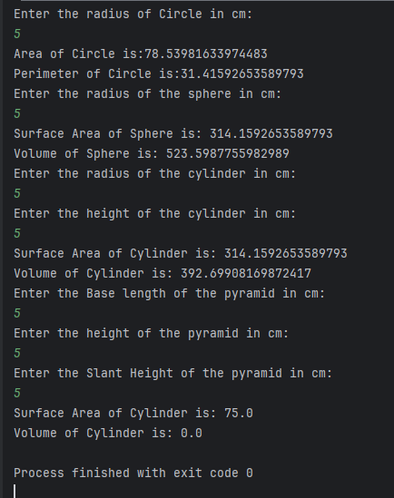**OUTPUT:-**

**Github:** <https://github.com/samarthpatel24/PIJ/tree/main/Assignment%205>